Week 11 – Week commencing 2/5/2022

**Week Outline**

Online meeting. This meeting was mainly used to discuss the final report plan and what topics needed to be covered and what need to be removed. Advised to rephrase more of the superconductivity stuff from the interim report and summarize it into a smaller chunk. Talk more about the methodology and analysis of the project. Several diagrams was also included by my supervisor to include in my report.

**Task Outline**

* Using the report plan, create a final report
* Use the recommendations in the final report

**Planned table of contents**

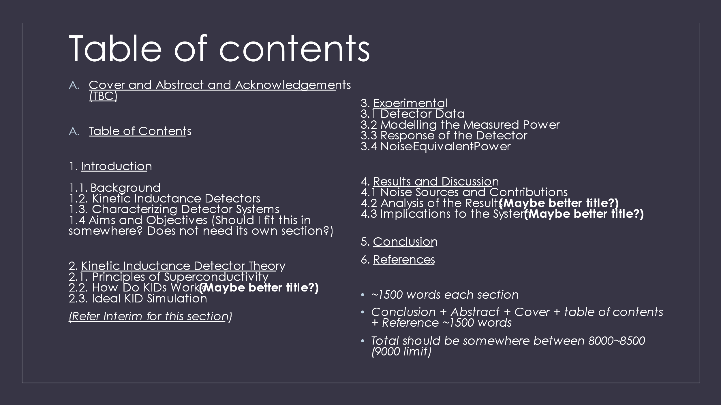

**Recommendations**

* Make sure under word limit by Turnitin
* Intro: describe photon noise, background, and KIDs overview
* Condense the superconductivity theory into less words
* Use lots of graphs and diagrams to aid explanations (words count, but diagram = 0 words)
* Touch upon more experimental stuff
* KID simulation and dF0 formula analysis is good to have in
* Explain photon noise limit and what implications if NEP higher? (excess noise, etc. Link to ERD)
* Noise sources? (explain?)

**Diagram of KID response given by Supervisor**

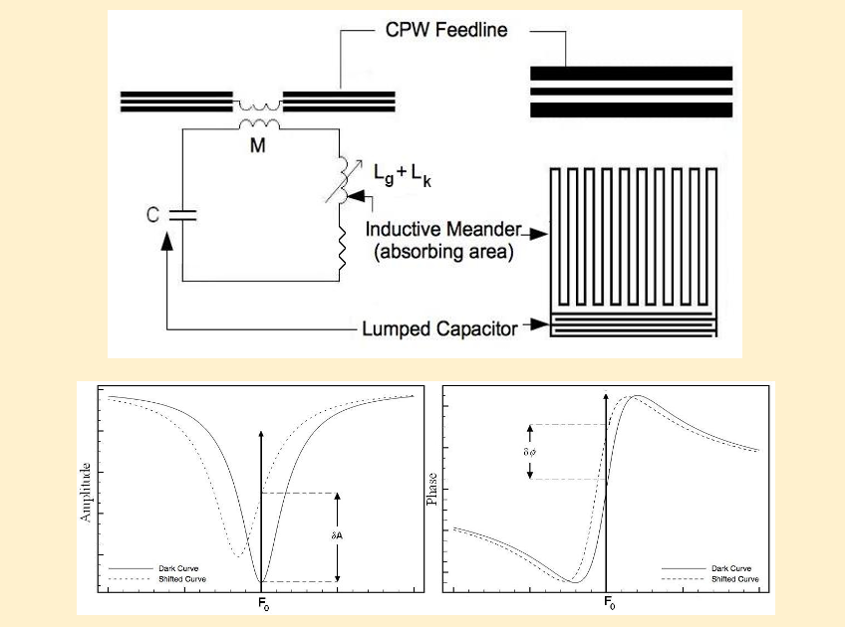

This diagram can be used to explain how a KID responds to light in the report